Open-ended experiment

Course Title: Algorithms Lab | Section: 4
Course Code: CSE2202 | Semester: Spring 2026
Total Marks: 40 | Submission Deadline: 25th April, 2026
General Instructions:
- This is an open-ended experiment. Students are expected to develop their own experiment;
- Show each step of your experimental procedure, data, and calculations;
- Discuss your results with relevant theories;
- Originality of the work is a must;
- Please refer to the assessment rubrics while preparing the report;
- Symbols, notations and abbreviations carry their usual meanings.

CO | Description | Domain/Model | Assessment Tools
CO1 | Apply programming skills and data structures to implement algorithms. | Cognitive / L2, Affective / L2,  Psychomotor/L2 | Open ended lab, Final exam
CO2 | Develop and implement algorithmic solutions to real-life problems. | Cognitive / L2, Affective / L2,  Psychomotor/L2 | Open ended lab, Final exam

Problem:
Consider a scenario based on the Traveling Salesman problem where the graph of cities to travel and their distances is given below:
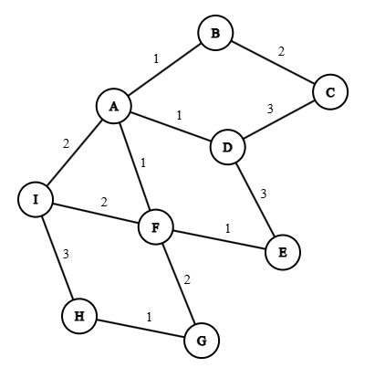

For this graph, write a program to solve the following problems:
- Calculate the Minimum Spanning Tree for the graph of cities
- Consider that the 9 different cities in alphabetical order have a “sales” value equal to the 9 different digits of your id (from left to right). Also consider that traveling along edges has a “cost” per unit of edge weight value (i.e an edge of weight 5 has a cost of 5). Calculate the profit (total sales – total cost) if the salesman travels in a way that he travels along all the edges of the Minimum Spanning Tree. This traversal can include visiting the same city more than once when backtracking.
- Apply at least two different algorithms to solve the problem (or parts of the problem) and compare their performances to find which algorithm performs best in this scenario.
Your submission for this task will be a lab report containing the diagram of your calculated Minimum Spanning Tree, screenshots/pictures with your program’s code, outputs for solving the problem using multiple algorithms as instructed and proof for which algorithm performs the best (using step size, asymptotic notation or other performance measuring methods). You can also submit your code separartely.

Note: You do not need to draw the MST diagram through your program, you can draw it by hand or using diagram tools and then attach the picture/screenshot in your lab report separately.

Open-ended features:
- Use modern tools.
- Showcase understanding of algorithms and their implementations
- Measure performance of algorithms
- Solve real-world problem using algorithms

Task No. | Corresponding COs | Marks
1. Demonstrate implementation of algorithms using programs | CO1 | 20
2. Showcase proper experimental operation and application of algorithms to solve practical problems. | CO2 | 20

